Project Report  
 On

**IoT BASED HOME AUTOMATION**

A Technical Mini-Project Report submitted in partial fulfillment of the requirement for the Degree of Bachelor of Engineering under C.V. Raman College of Engineering, An Autonomous Institute Affiliated to BPUT



**Guided By: Submitted By :**

**S.S PATANAIK AISHWARYAM ROMHARSHAN**



**C.V.Raman College of Engineering, Bhubaneswar**

**An Autonomous Institute Affiliated to BPUT**

**Department of ELECTRICAL ENGINEERING**

**C. V. Raman College of Engineering**

**CERTIFICATE**



This is to certify that the Project work entitled **“IoT BASED HOME AUTOMATION”**submitted by ***Aishwaryam Romharshan*** in Bachelor of Technology under Biju Pattnaik University of Technology, Rourkela, has been successfully carried out under the guidance and supervision of Asst. Prof. **S.S. PATTANIK** of the **Department of Electrical Engineering,** C. V. Raman College Of Engineering, Bhubaneswar.

**Signature of HOD Signature of External** **Signature of Project Guide**

**ACKNOWLEDGEMENT**

The Research Excellencies and an effective report design always needs the assistance from various sides. It was not possible on our part to give a complete and perfect touch without any assistance. Therefore we would like to express our indebtedness to our teacher incharge for his unfailing assistance, enthusiasm and ingenuity.

Firstly we would like to express our heartiest gratitude to **Asst. Prof. MS. S.S PATTNAIK (EE)** for her constant support and guidance.

Last but not the least we would like to extend our gratitude towards all the staff of **C.V. Raman College of Engineering** for their timely cooperation, initiative, administration, assistance and suggestion and much needed encouragement.

**ABSTRACT**

* In this project, we are going to make an IOT based home automation system using NODEMCU ESP8266 Wi-Fi module and. Using this we will be able to control home appliances through a web browser using your PC or mobile. These AC mains appliances will be connected to relays which are controlled by the NodeMCU ESP8266 and NodeMCU acts as a Web Server and we will send control commands through a Web Browser like Google Chrome etc. ESP8266 is the one of the most popular and low-cost Wi-Fi module available in the market today. The goal of this project is to develop a home automation system that gives the user complete control over all remotely controllable aspects of his/her home.

**CONTENT**

* Introduction
* Model description
* Circuit diagram
* List and specification of components
* Working principle
* Advantages
* Disadvantages
* Conclusion
* Reference

**INTRODUCTION**

* Wireless technologies are becoming more popular around the world and the consumers appreciate this wireless lifestyle which gives them relive of the well known “cable chaos” that tends to grow under their desk.
* The project aims at designing an advanced home automation system using NodeMCU ESP8266 module. The devices can be switched ON/OFF and read using mobile through Wi-Fi. The hunger for automation brought many revolutions in the existing technologies. These had greater importance than any other technologies due to its user-friendly nature.

**MODEL DESCRIPTION**

* The system has two parts, namely; hardware and software.
* The hardware system consists of NodeMCU board, Relay driver, and home appliances. The software consists of the Web page.
* In this system, the components used are NodeMCU board, the relay driver.
* When will on it will get messages on our screen which ever sensor will act we will get report on our screen of smart android phone.

**BLOCK DIAGRAM**

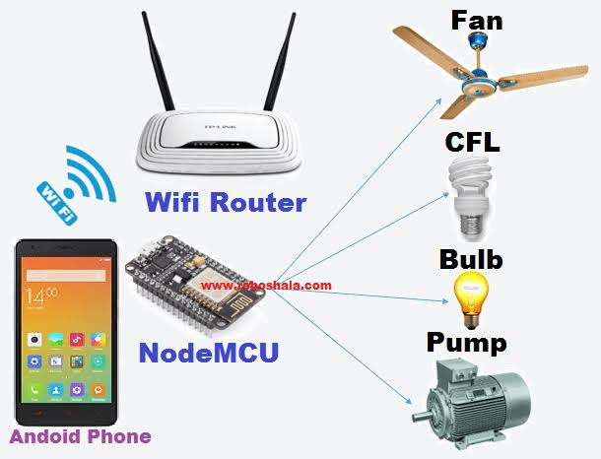

**CIRCUIT DIAGRAM**

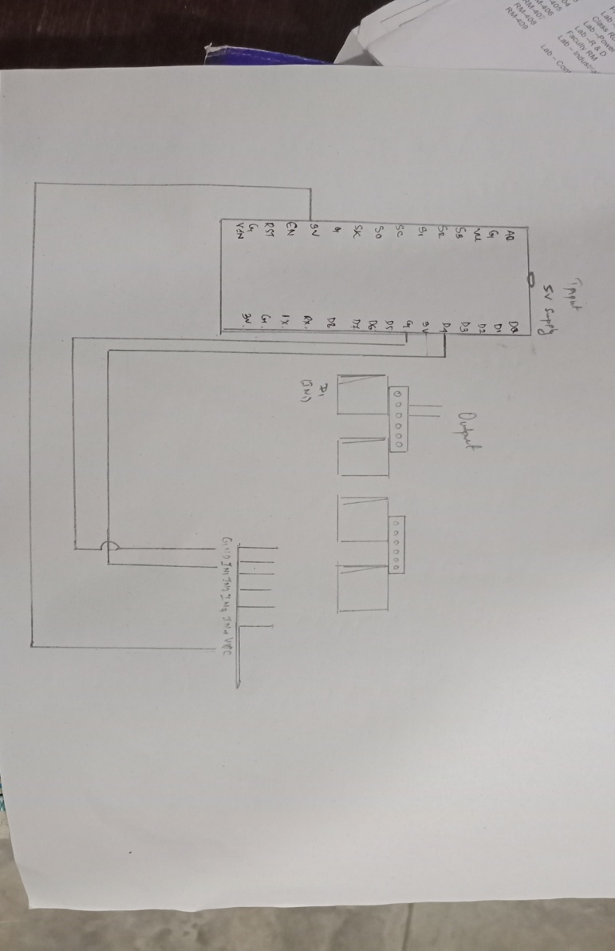

**LIST AND SPECIFICATION OF COMPONENTS**

* Node MCU 8266
* 5V 4 channel Relay module
* Jumper wires (female to female)
* AC 220V/120V loads/ Home Appliances
* Android Phone
* Normal bulb(5v)
* Small size AC fan
* Laptop/ PC

**NODE MCU 8266**

**WHY NODEMCU?**

1. NodeMCU is open source IoT platform.
2. Low cost.
3. Integrated support for the WIFI network.
4. Reduced size of the board.

Low energy consumption

**Relay module**

A **relay** is an [electrically](https://en.wikipedia.org/wiki/Electric) operated [switch](https://en.wikipedia.org/wiki/Switch). Many relays use an [electromagnet](https://en.wikipedia.org/wiki/Electromagnet) to mechanically operate a switch, but other operating principles are also used, such as [solid-state relays](https://en.wikipedia.org/wiki/Solid-state_relay). Relays are used where it is necessary to control a circuit by a separate low-power signal, or where several circuits must be controlled by one signal.

Use this 4 Channel Relay Module board to interface any Microcontroller with Electrical Appliances/Loads. Can also be used in driving high power motors.4-channel relay output modules, relay output contacts 250A 10A. Input IN1, IN2, IN3, IN4, the signal line LOW effective. VCC, GND power input, can relay a separate power supply relay power input of JD-VCC.

**ARDUINO CODING**

https://github.com/Aishwaryam-Romharshan/IoT-based-Home-Automation/blob/master/esp8266wifi.ino

WORKING PRINCIPLE

Home Automation usually is comprised of following main parts:

1. Main Controller
2. Interfaces

Main Automation Controller: The Main controller is usually a microcontroller. There are some systems that do use an actual home computer but these are usually not as reliable. The advantage to having a separate controller is its focus is only on all of the Home Automation tasks.  The controller we use hooks up to your home network and can access the Internet.

Interface: Automation occurs when the state of a device, product or system changes without any human interaction. It happens when your home enviorment is able to adapt to your needs all by itself=no tab of a button required.

APPLICATIONS

* This paper presents the overall design of Home Automation System (HAS) with low cost and wireless remote control.
* The design remains the existing electrical switches and provides more safety control on the switches with low voltage activating method.

The system intended to control electrical appliances and devices in house with relatively low cost design, user-friendly interface and ease of installation

**ADVANTAGES**

* It is a robust and easy to use system.
* There is no need for extra training of that person who is using it.
* All the control would be in your hands by using this home automation system.
* This project can provide the facility of monitoring all the appliances with in the communication range through wi-fi.
* By using this system the users can check the status of the appliances at whatever time of the day
* Manual control is also given in this project so the unskilled person can easily change the status.

**DISADVANTAGES**

* Wi-Fi is used in this home automation system, which have a rage 10 to 20 meters so the control cannot be achieved from outside this range.
* Application is connected after disconnect of the Wi-Fi.
* when the new users want to connect the first download application software then the code and configuration must be done.

**CONCLUSION**

* A Smart Home system integrates electrical devices in a house with each other. The techniques which are going to use in the home is the control of domestic activities, such as TV, fan, electric tubes, refrigerator and washing machine.
* In this paper we have introduced design and implementation of a low cost, flexible and wireless solution to the home automation. The system is secured for access from any user or intruder.
* This system can be used as a test bed for any appliances that requires on-off switching applications without any internet connection.

REFERENCES

* [www.electronicsforyou.com](http://www.electronicsforyou.com/)
* [www.howstuffworks.com](http://www.howstuffworks.com/)
* [www.wikipedia.org](http://www.wikipedia.org/)
* Electronics for you magazine